Dear Parent / Carer / Staff member
RE: Change in descriptors for thickening products
We are writing to you to alert you to the imminent change in the way the thickening products on the market will be describing different consistencies from April 2019. You may or may not already be aware of this.
As part of an international roll-out, the terms used to describe the level that your child has his/her thickened drinks will be changing. You will mainly notice these changes on your child’s written reports and possibly the instructions on the thickener product that you use. However, this will not change what you are currently doing, unless otherwise advised by your child’s Speech and Language Therapist (SLT).
Please see diagram below to aid your understanding of how this will change:
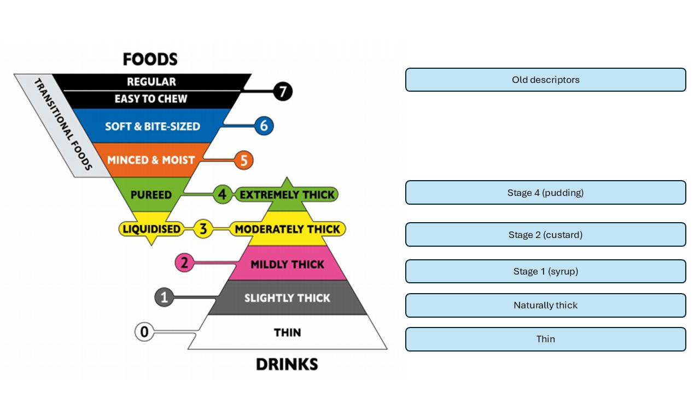
The measurements for the thickener you currently use will remain the same as you have discussed and agreed upon with your SLT. Please note: some manufacturers may have changed their packaging to reflect these changes already. We hope this is clear. If you have any questions or concerns about this, please contact your local SLT who will be happy to discuss this more with you.
Kind regards, The SLT Paediatric Dysphagia team.

